# Chapter 3: System Analysis

## 3.1 System Analysis

### 3.1.1 Requirement Analysis

#### i. Functional Requirement

**Customer**

* View the products
* Create the profile profile
* Search for products
* Create and view the order history
* View Recommendations provided

**Admin**

An admin should be able to perform the following activities within the system:

* List the products
* Add/Update/Remove category
* Add/Update/Remove products avaibale
* View the customer details
* View orders

Our system allows two user privileges, one is the admin and the other is the customer. The different activities that can be performed by thr users in our system have been mentioned in the above points. And, the Use Case diagram below presents the same in a graphical format.

**Use Case Diagram**

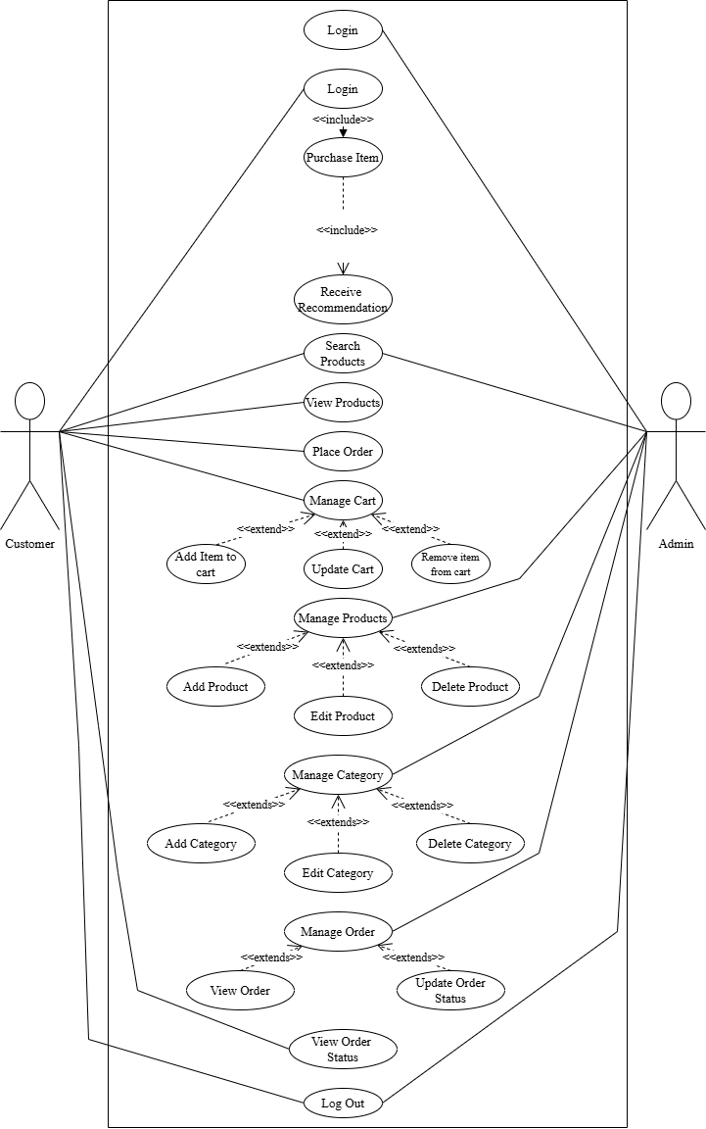

**Hardware Requirement**

The hardware requirement for the project includes a laptop with support HTML5, CSS, and other implementation tools required for the project. The minimum system requirements for the laptop include i5 13th Gen, 8 GB RAM, 512 SSD, Windows 11 professional. As the final goal the system is to be hosted and be accessible by anyone, we have studied a few hosting providers which include World Link, Web Host with average cost rating from as low as RS. 20.00 to as high as RS. 65,000.00 with its own set of features provided accordingly which will be implemented in the future.

**Software Requirement**

The software requirements for the project include implementation tools like Visual Studio Code, SQL server all of which are open-source programs so can be utilized in the project without any additional costs.

Draw.io is used to prepare the necessary diagrams for the project, both of which are open source so no additional cost is required.

#### ii. Non – Functional Requirements

* **Performance :** It should be ensured that the system provides fast loading, rides high traffic efficiently , and also ensures excellent management of the database so as to make acess to products and user details speedy.
* **Scalability :** The developed platform has to be such that it scales with growth in a product catalog, user base, and possibly features like international shipping or new product categories.
* **Security :** Observe the best practices in cyber security, secure user authentication and data encryption, protection against SQL injection and XSS. Ensure the protection of users' data according to GDPR.
* **Usability :** Easy to use and intuitive, simple navigation. Many accessibility features should be included for all types of users that may use it, such as disabled persons.
* **Sustainability :** Green servers, powered by renewable energy or running carbon offsetting schemes, host the site, and sustainable web design practices are in place to reduce the carbon footprint of the website.

### **3.1.2 Feasibility Analysis**

A feasibility study, also known as feasibility analysis, is an analysis of the viability of an idea. It describes a preliminary study undertaken to determine and document a project’s viability. The results of this analysis are used in making the decision whether to proceed with the project or not. In short, a feasibility analysis evaluates the project’s potential for success, following feasibility analysis was performed prior to working on the project.

#### Technical

Eco-Bazaar will be built with dependable, user-friendly, and scalable technologies: HTML, CSS, JavaScript, and Django for the backend, and MySQL. These technologies are well-established with a good history of support, hence the assurance of handling the anticipated load of users without affecting their seamless shopping experience. Integration of real-time data processing, secure payment systems, and other features with personalized recommendations can be achieved through a judicious combination. The scalability and flexibility required as the platform grows will be provided by cloud hosting services.

#### Operational

The Eco-Bazaar will be user-friendly and intuitive, thus requiring minimal training for users and administrators. At the back end, the platform will include an easy-to-use admin panel for managing products, orders, and customer interactions. The introduction of eco-friendly shipping and packaging options goes hand in glove with the platform's goals on sustainability, making this very attractive to the targeted audience.

#### Economic

Eco-Bazaar's development and maintenance costs are within reasonable budgetary limits. The initial investment includes the cost of development, domain registration, hosting, and marketing. These would be offset by the revenue streams that the platform generates through commissions on sales, subscription plans, and advertisement placements to ensure profit occurrence. Thus, Eco-Bazaar would stand in a better position to witness sustainable revenue growth in the long term with the rising consumer demand for eco-friendly products.

#### 4 . Schedule (Gantt Chart)

The development timeline for Eco-Bazaar is rather realistic, with a phased approach toward implementation. It aims to complete the core features of user registration, product catalog, search functionality, and secure payments within the first six months. Continuous testing and feedback loops will ensure the platform's launch on time and satisfy users' expectations.

Given below is a Gantt chart describing the schedule for our project:

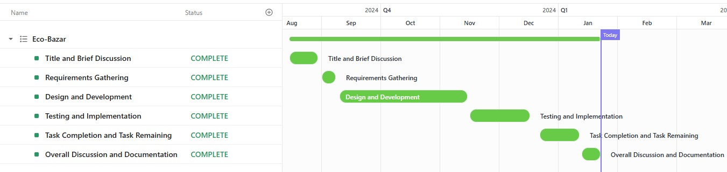

* + 1. Analysis

Flowchart

Flowchart for customer

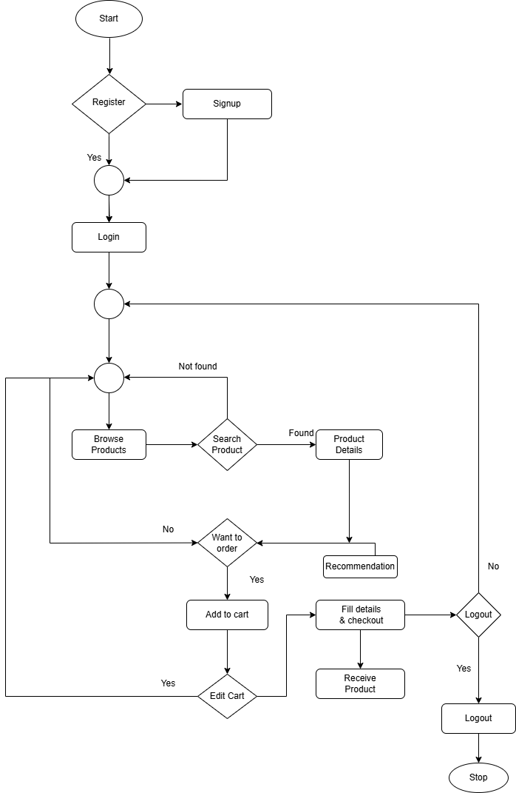

Flowchart for admin

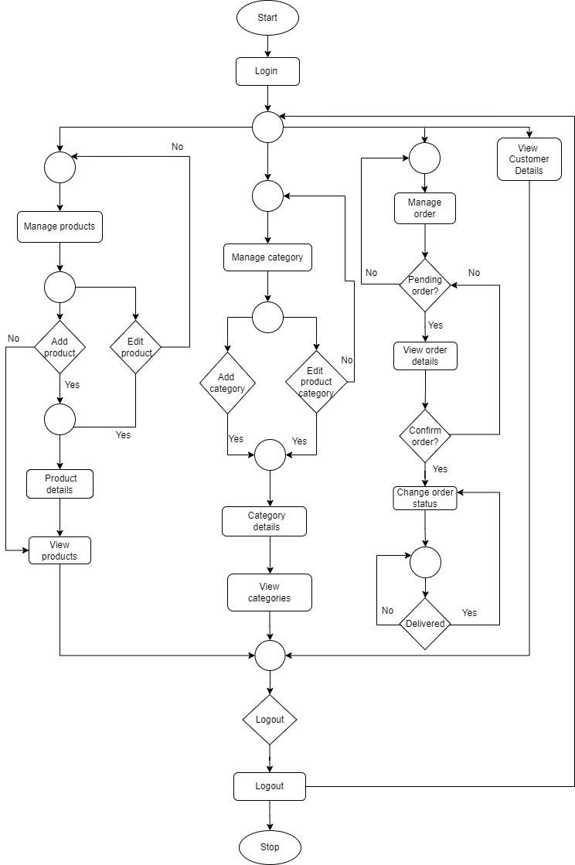

ER Diagram

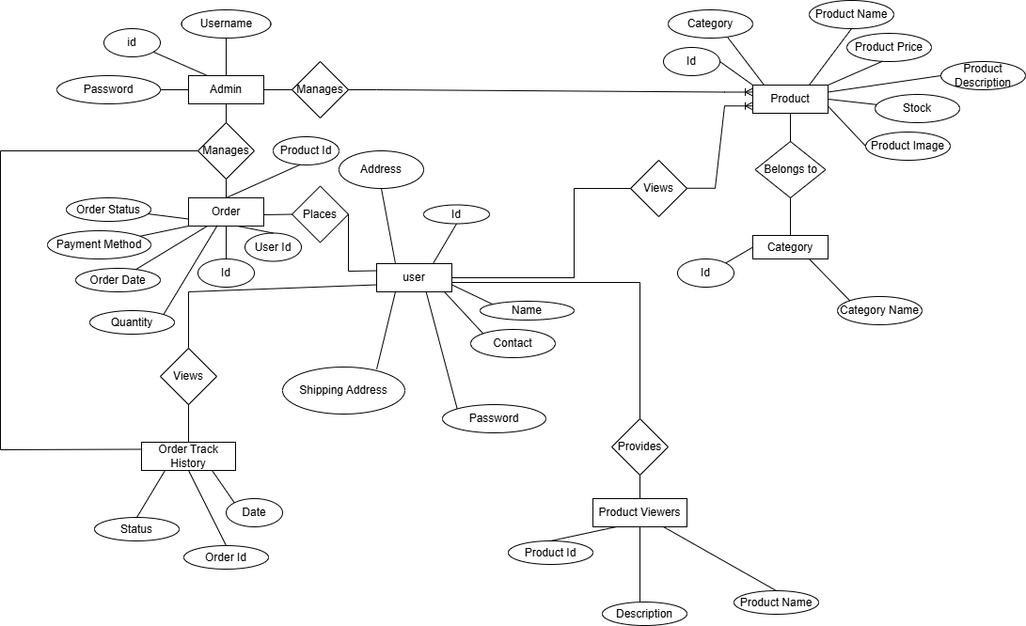

DFD

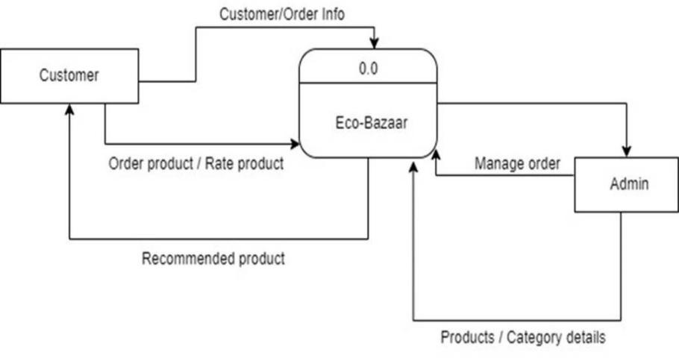

DFD Level 1 for admin

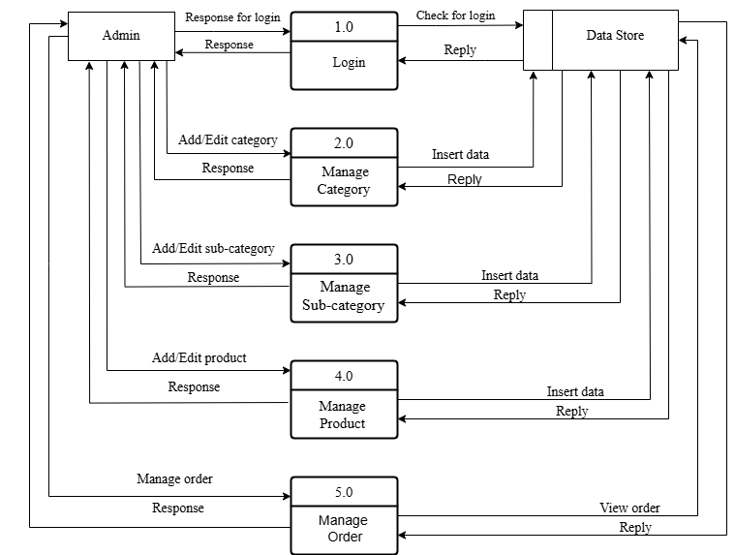

DFD Level for customer

